


Confederation of Hunting Associations of SA
Tel +27 41 922 5600 Box 1614 Uitenhage 6230
Cel +27 82 523 8201 chasa@telkomsa.net
Fax +27 41 922 5600 www.chasa.co.za

10 July 2006

Victory for firearm ownership and citizen freedoms

From 26 June to 7 July in New York, the United Nations hosted a two week long conference named ‘United Nations Conference to Review Progress Made in the Implementation of the Programme of Action to Prevent, Combat and Eradicate the Illicit Trade in Small Arms and Light Weapons in All Its Aspects’.

This conference was very much the culmination of years of work by the anti-gun lobby in general, but in particular by the global campaign, jointly launched in October 2003 by the International Action Network on Small Arms (IANSA), Oxfam and Amnesty International.

IANSA is a global network of more than 700 NGO’s members that “work for controls on the international arms trade and for laws to make people safer from gun violence”. IANSA is run by Rebecca Peters, an Australian, and have as members from South Africa,
- Gun Free South Africa (GFSA), Braamfontein (Adele Kirsten)
- Institute for Security Studies (ISS), Pretoria (Sarah Meek)
- Amnesty International, Pretoria
- Centre for Conflict Resolution (CCR), University of Cape Town
- Coalition for Peace in Africa - Action Support Centre, Melville
- Congolese Association for Peace & Development (ACOPAD), Rivonia
- Peace & Security Program, University of Witwatersrand
- Safer Africa, Arcadia.

When seeking public support, the campaign is projected as to focus on promoting an international treaty to cover arms transfers. In reality, the campaign actually goes beyond this, in seeking also a tightening of national firearms legislation world wide (as South Africa has witnessed since 2004) as well as official linking by the UN of “gun control” to “development”. The latter presents itself as a legal way of funding the anti-gun campaign from international funds earmarked for ‘development’.

In the week leading up to the conference, conference chairman Prasad Kariyawasam has received more than 100,000 letters of complaint from Americans who want the U.N. to stay out of the business of regulating lawful gun ownership in the United States. This prompted UN Secretary General Kofi Annan to open the conference with a statement to the extent that it was not the Conference's purpose to ban "law abiding citizens right to bear arms".

IANSA attended in force, with a message that “IANSA's 700 members stand ready to work alongside governments and international organisations to further implement the Programme of Action and the recommendations to be issued by this Review Conference. Although it is the responsibility of governments to ensure that action is taken, we are ready to offer our expertise and energy to make this vision a reality”.

South Africa’s delegation was led by Ambassador Sipho George Nene and included CFR Head, Jaco Bothma.

The Conference ended in deadlock on Friday, with no formal conclusions or recommendations – a total failure.

IANSA saw it as:

“Despite the efforts of the majority of governments to secure real change, the long awaited UN Small Arms conference has ended in failure. Hijacked by a small number of states, notably the US, the conference failed to agree on any measures at all to address the global gun crisis. It is to their lasting shame that governments let this happen: they allowed a small number of states to hold them all hostage and to derail any plans which might have brought improvement in this global crisis. The conference should have provided a clear framework for governments to protect people from gun violence. But it ended in acrimony and frustration as agreement on almost all the major issues was blocked by a handful of states, and no outcome document could be agreed.

Before talks collapsed completely late today, obstruction had occurred in the following areas:
• Progress on global standards for international arms transfers – which would prevent exports to destinations where they might be used for human rights violations – was obstructed primarily by Cuba, India, Iran, Israel and Pakistan.
• Discussion on how strengthening national laws can prevent gun deaths was blocked by the USA.
• The US refused to allow the conference to acknowledge the impact of small arms proliferation on ‘development’.
• Despite professing concern about the human cost of small arms violence, governments failed to agree to provide support for the survivors of gun violence.
• The US was instrumental in preventing any follow-on global meetings to discuss the small arms trade.”

The NRA report it as:

“Day One - Monday, June 26, 2006
The UN "Small Arms" Conference opened today. Antigun NGOs were out in force, but the NRA and other pro-gun rights organizations were also present.

Day Two - Tuesday, June 27, 2006
The UN "Small Arms" Conference entered its second day with more country statements being delivered to the delegates gathered in the General Assembly Chamber. The highlight of today's meeting was the United States statement delivered by U.S. Under Secretary of State Robert Joseph. Joseph politely but forcefully gave the U.S. "red lines" - issues which the U.S. strongly opposes and will not allow into any Conference report or recommendations. These included interference with Americans' Right To Bear Arms, a UN ban on transfer of arms to freedom fighters and international regulation of ammunition. The U.S. also said it was not ready to commit to any future conferences on small arms.

Day Three - Wednesday, June 28, 2006
A new draft of the UN "Small Arms" Conference "final" report became public on this third day of the meeting. Unfortunately, the draft contained provisions on two issues the U.S. considers "Red lines" and will not accept - a UN ban on transfer of arms to freedom fighters and international regulation of ammunition. The proposed document also calls for UN meetings on "small arms" up to and including another conference in 2012. The U.S. is opposed to these constant meetings which seem to rehash the same issues.

Day Four - Thursday, June 29, 2006
Day four of the UN Small Arms Conference had several highlights. The Swiss Small Arms Survey (an anti-gun think tank) released its book supporting international regulation of ammunition. Although the U.S. continues to strongly oppose the inclusion of ammunition in any Conference report, several countries insist on pushing the concept.

Day Five - Friday, June 30, 2006
The fifth day of the UN Small Arms Conference saw non-governmental organizations make statements to the meeting

Day Six - Monday, July 3, 2006
The UN Small Arms Conference ground into its sixth day with innumerable speeches and very little action.

Day Seven - Wednesday, July 5, 2006
The issue of UN regulation of civilian firearms raised its ugly head again. The move was led by Mexico, Colombia and of all countries - Canada. Many observers were chagrined that the Canadian delegation would take such an anti-gun stand even though there is a new Conservative government in Toronto. Canadian disarmament bureaucrats seem to be running the delegation. The U.S. held firm on the issue of civilian firearms.

Day Eight - Thursday, July 6, 2006
Diplomats continued to battle over key issues as the Conference entered its next to last day. The concept of UN regulation of civilian firearms seems to refuse to die, even though the U.S. is adamantly holding the line on the issue.

Day Nine - Friday, July 7, 2006-07-10
The Conference ended in deadlock, with no formal conclusions or recommendations. In the final analysis, the complexity of the issue and the concerns of hunters, sport shooters and firearms owners world-wide prevailed. No recommendations on ammunition, civilian possession or future UN meetings, or for that matter any other subjects, were adopted.”

This outcome represents a major victory to firearm owners, and we should certainly celebrate it (and thank the Bush administration). We must however, not relax for one moment in our crusade to protect our freedom, as this victory may be a very temporary one. Not only has Rebecca Peters committed her organisations to continue their cause, but Hillary Clinton - touted as the next US President - is claimed by Oxfam to be a staunch supporter of their work.

Regards

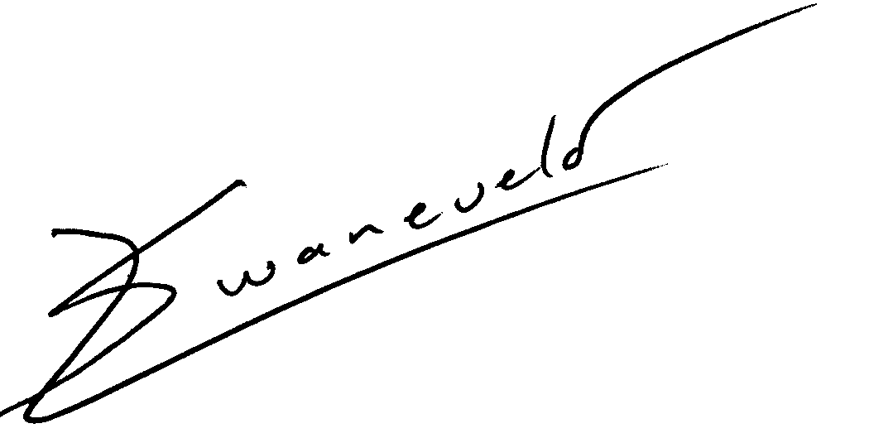

Ludolph Swanevelder
Chair: CHASA

